**BA EXPERIMENT 5**

**CARS_PRICING:**

**Crosstab:**

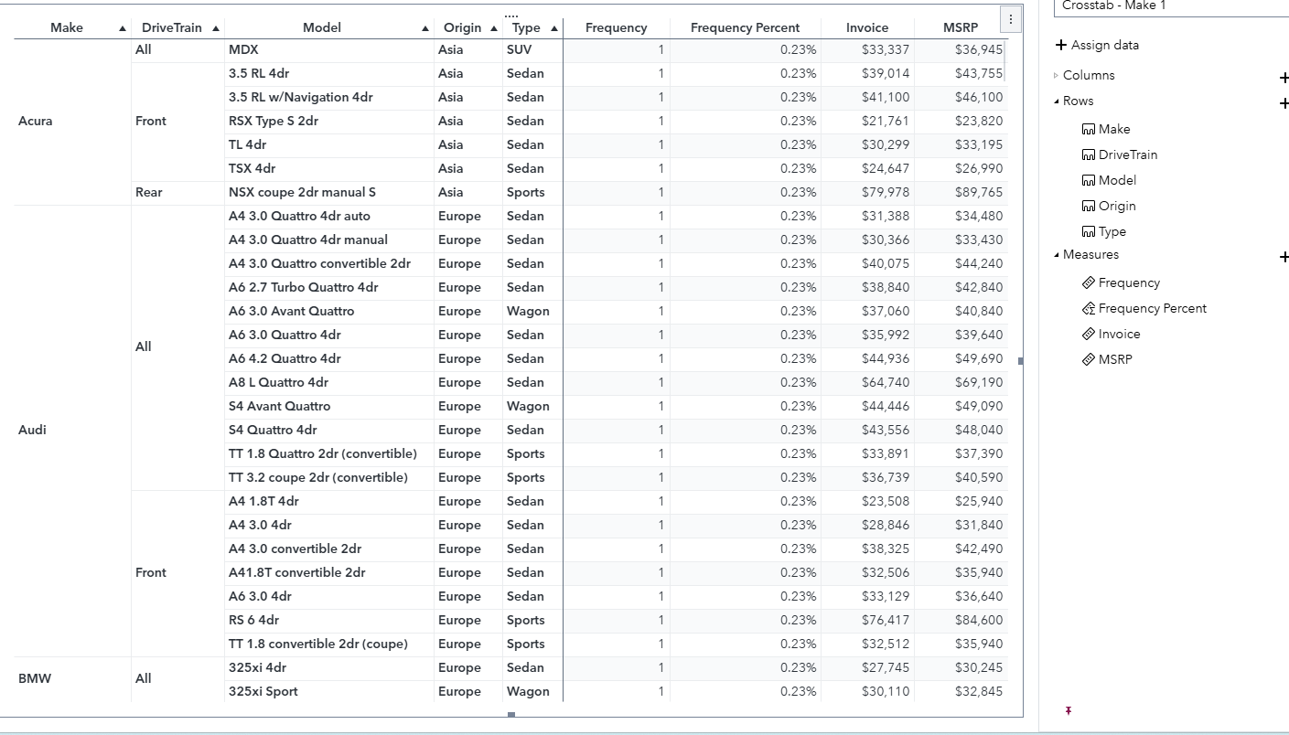

**List Table:**

